**Introduction**

The Organ Donation App is an integrated mobile and web-based platform designed to facilitate communication and management between patients seeking organ transplants and hospitals providing them. This app aims to streamline the organ donation process by offering essential functionalities, such as organ match identification, organ requests, and direct communication with hospitals. The platform is structured into two main components:

**Mobile Application:** Primarily designed for end-users (patients), the mobile app enables users to search for organ matches, request organs, and communicate directly with hospitals. It provides a user-friendly experience that guides patients through requesting an organ, receiving match notifications, and sending messages to hospital representatives.

**Backend Management Panel:** Accessible to hospital administrators and medical personnel, the backend panel serves as a centralized hub for managing patient requests, responding to messages, approving or denying organ requests, and monitoring overall user interactions. This panel streamlines administrative workflows, ensuring that hospital staff can manage cases efficiently and reach out to patients seamlessly.

**Backend Management Panel**

**01 Login**

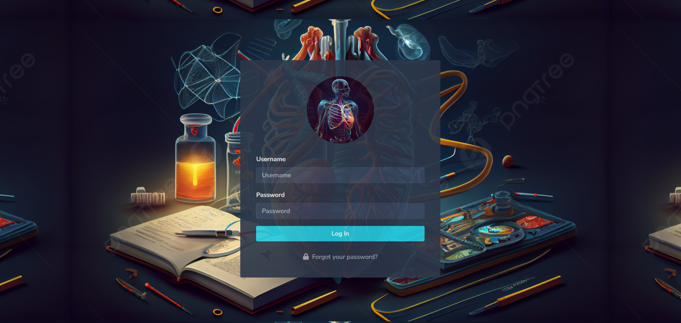

The login screen is the gateway for users to securely access the Organ Donation App, the interface provides a clean and user-friendly layout where users can input their credentials. The app ensures secure authentication, allowing only verified users to access the platform. Upon entering their username and password.

**Features:**

* **Login:** Allows users to securely enter their username and password to access the app.
* **Password Incorrect Check:** The system notifies users if the entered password is incorrect, ensuring clear communication for failed login attempts.
* **Session Handling:** Once logged in, the app manages user sessions securely, keeping the user authenticated throughout their interaction and ensuring their data remains private.

This login screen provides a secure, reliable starting point for users to access the app's functionalities, enhancing the overall user experience through intuitive design and secure authentication mechanisms.

**02 Dashboard**

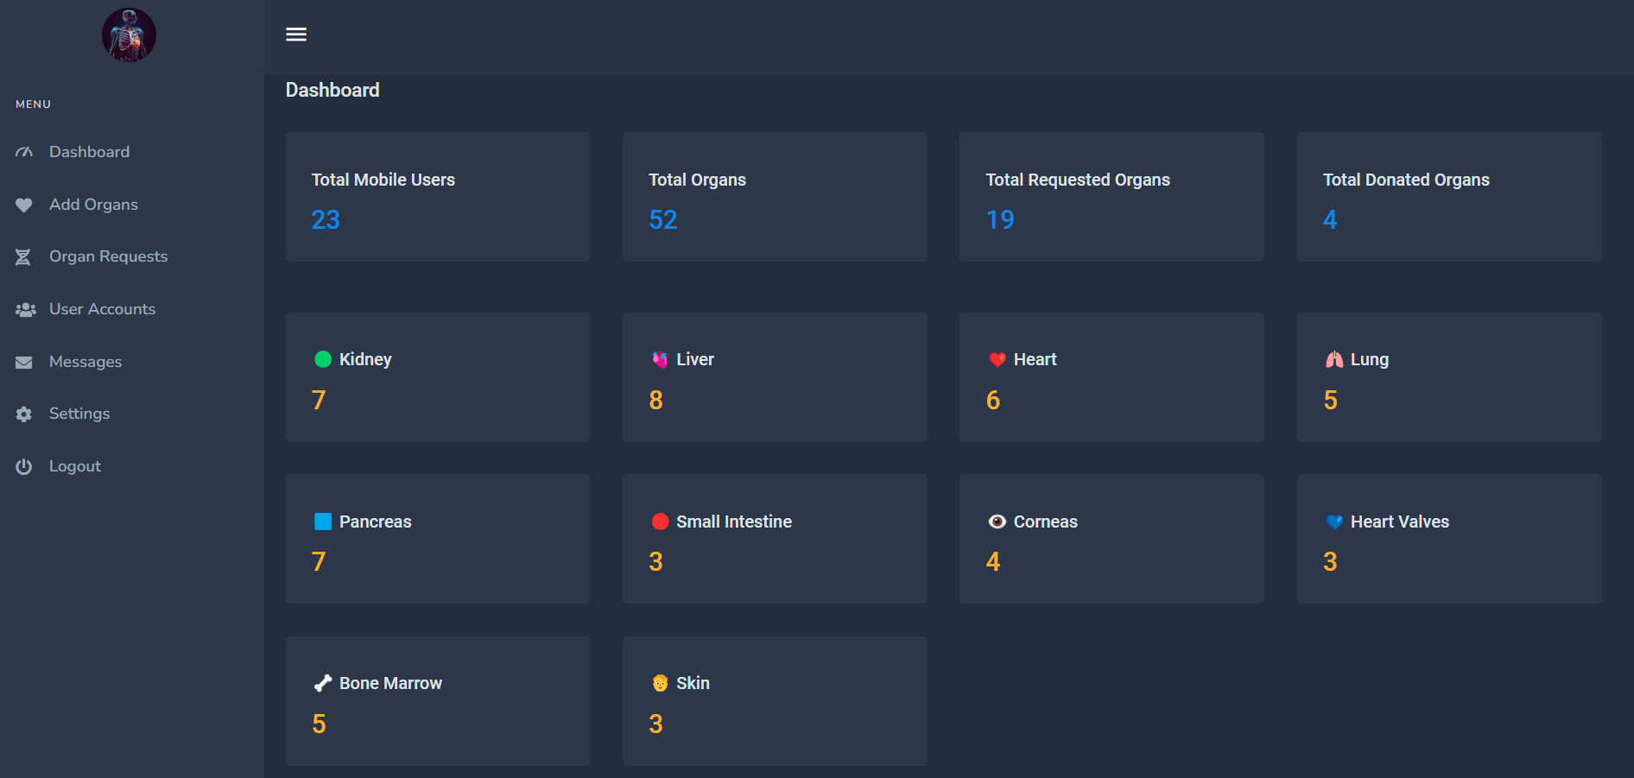

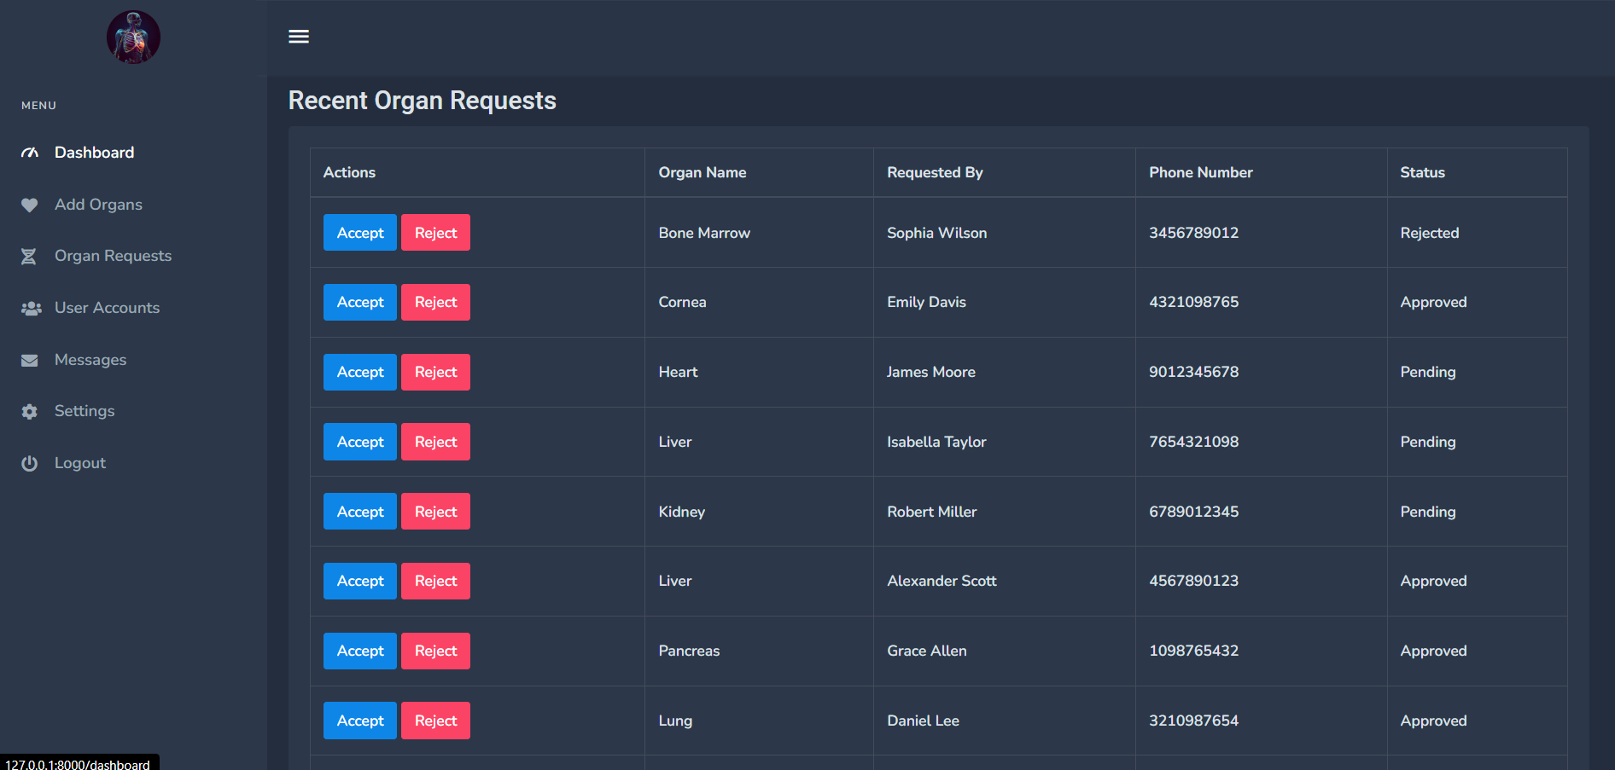

The dashboard is the central hub for managing and viewing organ donation data within the Organ Donation App backend panel. Designed with a clean, intuitive layout, it provides quick access to essential statistics, such as the total number of mobile app users, organ types, requested and donated organs. Additionally, the dashboard showcases the latest 10 organ requests to help hospitals track recent activities in real-time, allowing them to respond efficiently.

**Features:**

* **Total Mobile Users:** Displays the current count of mobile app users, helping administrators gauge user engagement.
* **Total Organs:** Provides an overview of all available organs, categorized by type for easy reference.
* **Total Requested Organs:** Shows the number of organs requested by users, assisting in tracking demand.
* **Total Donated Organs:** Displays the total number of organs donated, highlighting the app’s impact.
* **Organ Categories and Counts:** Lists each organ type (e.g., Kidney, Liver, Heart, etc.) along with a specific count, offering a quick view of available inventory.
* **Latest Organ Requests:** Shows the 10 most recent organ requests, allowing hospital administrators to prioritize and act on urgent cases.

.

**03 Add Organs**

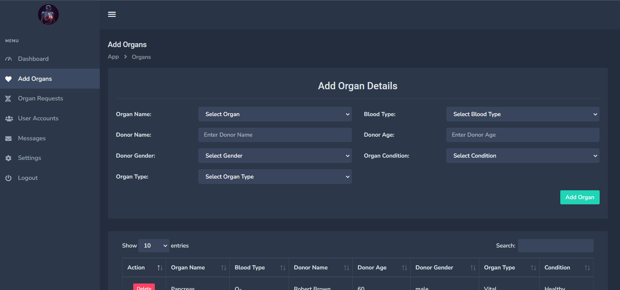

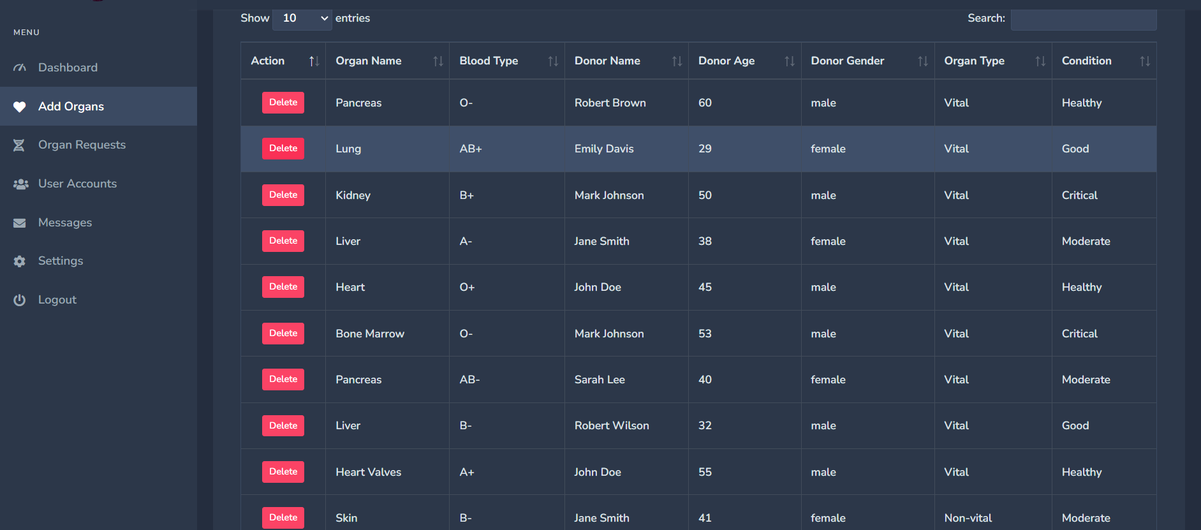

The Add Organ section is a key part of the Organ Donation App's admin dashboard. This section allows authorized users, typically hospital staff or administrators, to enter detailed information about available organs for donation. Each organ entry includes specific details about the donor and the condition of the organ, providing crucial information that helps in matching donors with potential recipients.

The interface for adding organs is intuitive, with dropdown selections for fields like organ type, blood type, donor gender, and condition, while text fields allow the input of donor-specific information such as name and age. Once entered, the data is displayed in a well-organized table below, which includes sorting, filtering, and search functionality for ease of management. Each organ entry can also be deleted if necessary, making the database both dynamic and accurate.

**Features:**

* **Organ Entry Form:** Allows detailed information input for each organ, including donor details.
* **Dropdown Menus for Easy Selectio**n: Dropdowns for organ type, blood type, and other fields to streamline data entry.
* **Real-time Table Display:** Shows a list of all entered organs with relevant details in a structured format.
* **Search and Filter:** Quickly locate specific entries using the search and filter functions.
* **Delete Functionality:** Remove organ entries easily to ensure up-to-date information.
* Organ Count Display: Displays a count for each organ type, giving a quick overview of available inventory.

**04 Organ Requests**

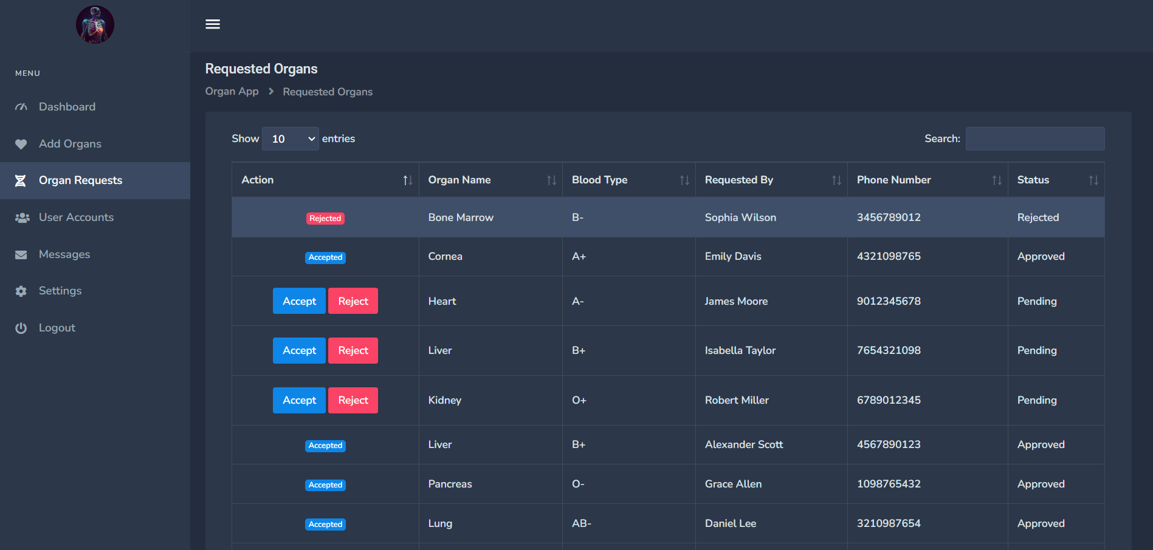

The Organ Requests section is an essential feature of the Organ Donation App's admin panel, designed to manage organ requests from patients through the mobile app. In this section, the hospital administrators can review each organ request, which includes details about the requested organ type, the blood type of the patient, the requester’s name, and their contact information.

Once a request is reviewed, hospital administrators, in consultation with medical professionals, can decide whether to accept or reject the request. Each request has an "Accept" or "Reject" option, and once an action is taken, the status of the request is updated accordingly. This allows the hospital to efficiently communicate the outcome back to the requester and manage organ availability in real-time.

**Features:**

* **Organ Request Details:** Displays detailed information for each organ request, including requester information and blood type.
* **Approval System:** Allows administrators to accept or reject requests based on medical feasibility.
* **Status Tracking:** This feature shows the current status of each request (Pending, Accepted, or Rejected) with color-coded badges for easy identification.
* **Real-time Update:** As requests are processed, the system updates the request status, ensuring accurate communication and tracking.
* **Search and Filter Functionality:** Easily locate specific requests through the search bar and sort options.

**05 Mobile User Account Management**

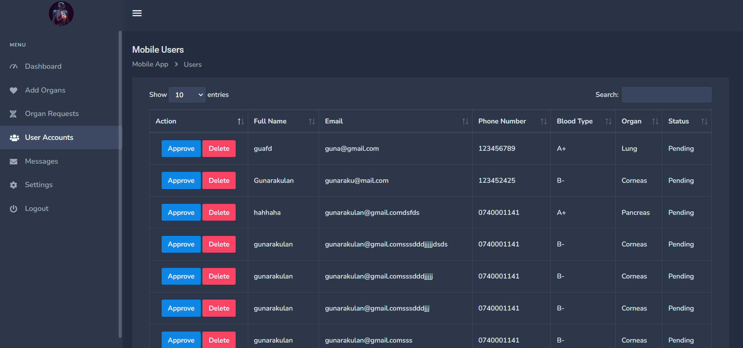

The Mobile User Accounts section in the admin panel of the Organ Donation App is a centralized feature for managing user accounts of individuals registered on the mobile app. In this section, hospital administrators can monitor and control mobile app users, viewing their essential information and managing their account status.

Each row in the user list displays details like the user’s full name, email, contact information, blood type, and requested organ. Administrators have the option to either approve or delete user accounts. This functionality is particularly useful for verifying new users before granting access or for removing accounts that are no longer valid or do not meet the criteria.

**Features**

* **User Details Display**: Provides detailed information about each user, including contact details, blood type, and organ preferences.
* **Approval System**: Allows administrators to approve user accounts for access to the app’s features or delete accounts if necessary.
* **Pending Status Display**: Displays the status of each account (Pending) until action is taken, ensuring a smooth onboarding process.
* **Control Panel Access**: Administrators can manage user approvals efficiently, ensuring the user base is composed of verified individuals.

**06 Messaging**

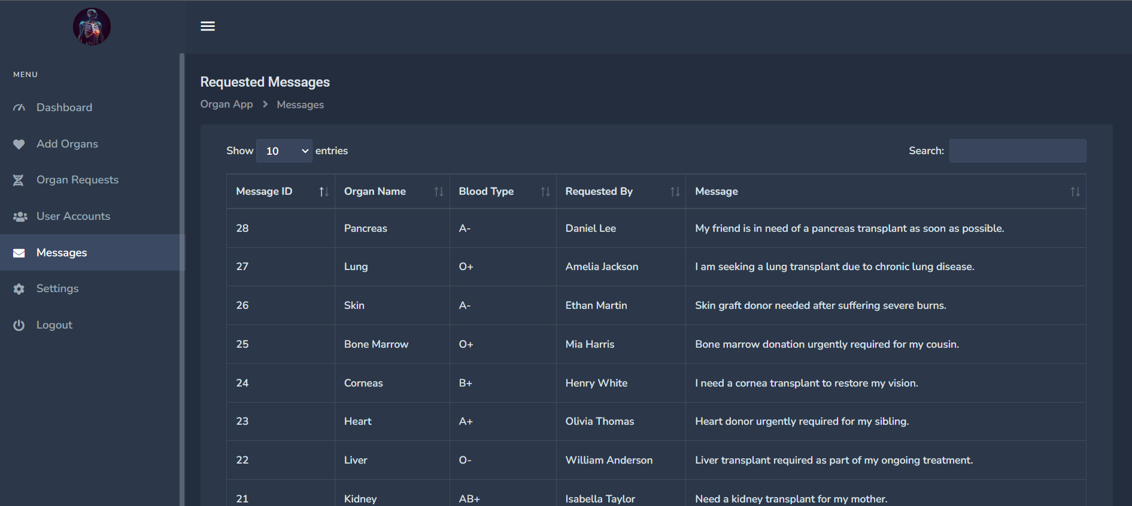

The Messages section in the Organ Donation App admin panel allows hospital staff to review urgent requests sent by mobile users. In this feature, users can submit messages specifying their required organ, providing essential information like organ name, blood type, and a personalized message describing their needs. This functionality is designed to facilitate quick communication between patients and hospital representatives, making it easier for hospital staff to assess the urgency of each case and respond accordingly.

**Features**

* **Message Display**: Lists all messages submitted by mobile app users with details like Message ID, Organ Name, Blood Type, Requestor’s Name, and the personalized message.
* **Organ Information and Blood Type Matching**: Each message includes the requested organ type and blood type, allowing staff to identify compatible matches more efficiently.
* **Direct Communication**: Hospital staff can review the message details and reach out to the user directly via phone or email to provide further assistance, ensuring a streamlined response.
* **Search and Filter**: The interface supports search functionality, allowing hospital staff to filter through messages and prioritize cases based on urgency or specific organ requests.

**07 Settings**

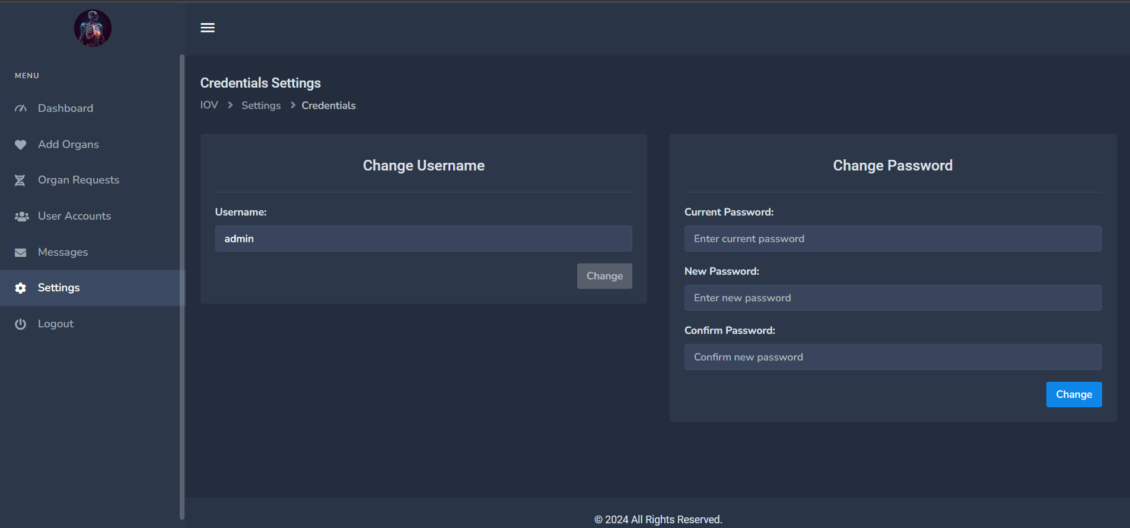

The **Settings** page in the Organ Donation App's admin panel provides the hospital admin with the ability to manage their account credentials, specifically the username and password. This feature ensures secure access to the backend panel, allowing the admin to regularly update their login information for enhanced security. The settings page is straightforward, with dedicated sections for updating both the username and password.

**Features**

* **Change Username**: Admins can update their username to a preferred choice for personalized access.
* **Change Password**: A secure process for changing the password, requiring the current password to validate the user’s identity.
* **Confirm New Password**: Ensures accuracy by prompting the admin to re-enter the new password to avoid any typographical errors.

**Mobile App**

**01 Get Started Screen**

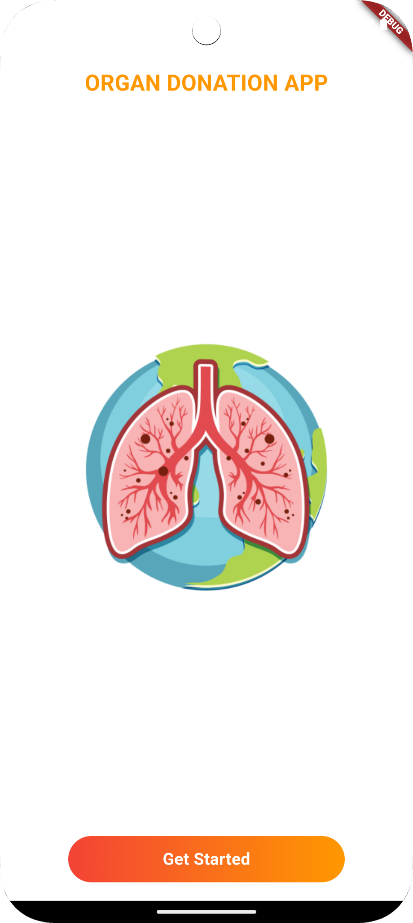

The Get Started screen is the welcoming interface of the Organ Donation App mobile application, designed to provide users with a warm and engaging introduction to the app. This screen features a prominent illustration of a vital organ (symbolizing the mission of the app) on a globe background, representing the global impact and significance of organ donation. The "Get Started" button at the bottom guides users into the main functionality of the app, creating a seamless transition from introduction to interaction.

* **Engaging Design**: The screen includes a graphic that symbolizes organ donation, setting a compassionate tone for the app.
* **Clear Call-to-Action**: The "Get Started" button is brightly colored and positioned at the bottom, making it easy for users to proceed with their journey in the app.

**02 Request Organs Explanation Screen**

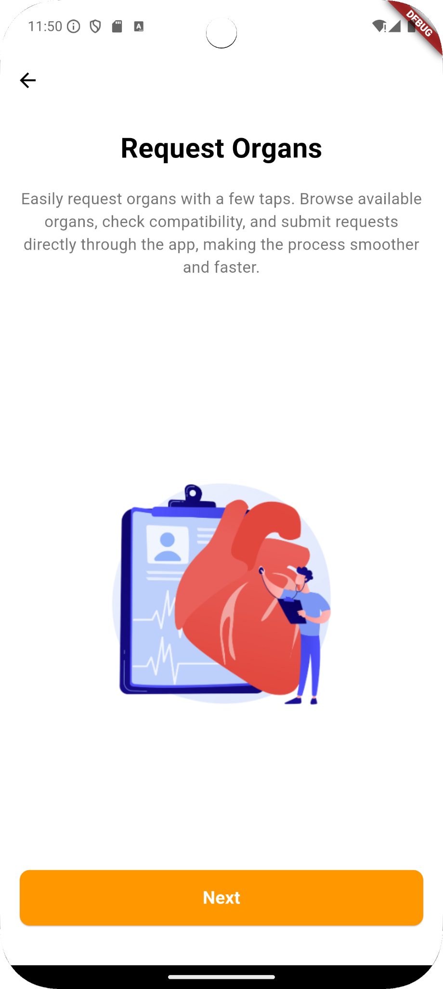

The **Request Organs** walkthrough screen introduces users to one of the primary features of the **Organ Donation App**. This screen provides a brief overview of the organ request functionality, allowing users to understand how they can quickly and easily request a needed organ through the app. With a straightforward design, users are guided to proceed through the app, enhancing the overall onboarding experience.

* **Feature Introduction**: Briefly explains the organ request feature, ensuring users understand the benefits and ease of submitting a request.
* **Visual Guide**: An illustration emphasizes the organ donation theme, helping users connect emotionally with the app's mission.
* **Clear Navigation**: The "Next" button allows users to continue exploring the app's features, providing a smooth onboarding flow.

**03 Match Found Explanation Screen**

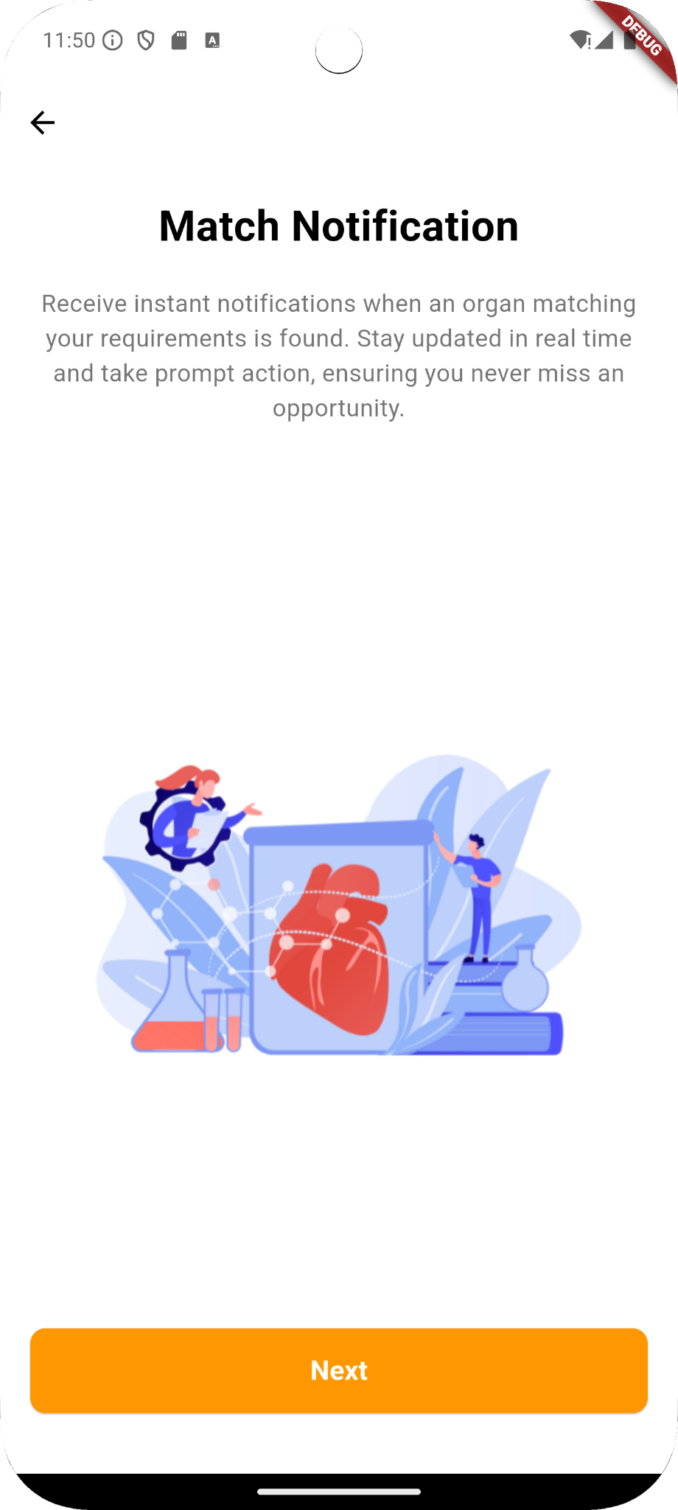

The **Match Notification** walkthrough screen in the **Organ Donation App** informs users about the notification feature, which alerts them instantly when an organ matching their requirements becomes available. This functionality is crucial for users seeking a specific organ, as it keeps them updated in real-time, allowing them to respond promptly. The screen visually reinforces the importance of timely notifications, helping users feel reassured about staying informed.

* **Instant Notifications**: Users receive alerts as soon as matching organs are available.
* **Real-Time Updates**: Keeps users informed to take immediate action.
* **Ease of Access**: A “Next” button helps users move smoothly through the setup, ensuring a seamless onboarding experience.

**04 Search Organs Explanation Screen**

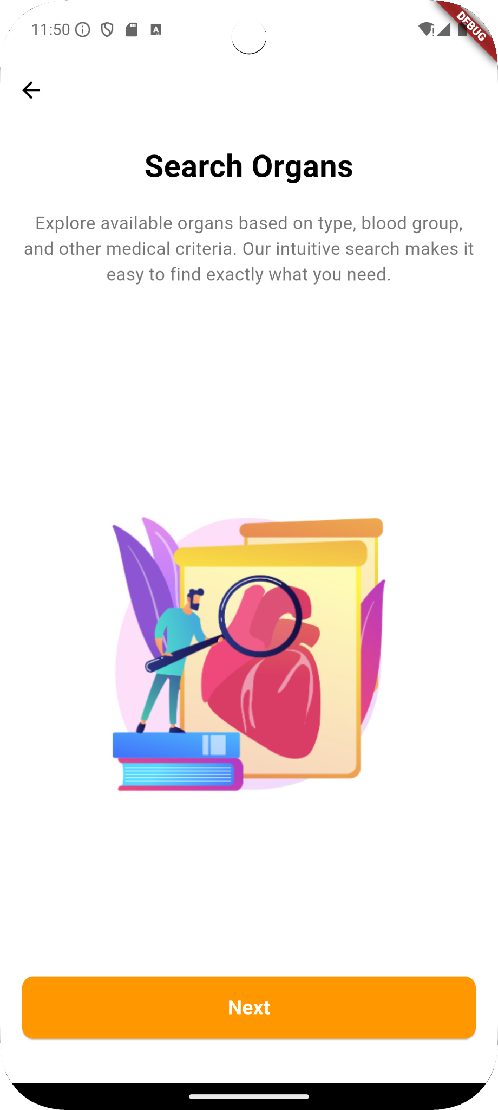

The **Search Organs** walkthrough screen in the **Organ Donation App** highlights the app’s powerful search functionality, enabling users to explore available organs based on specific criteria such as organ type, blood group, and other medical factors. This feature allows users to quickly find matching organs that meet their needs, streamlining the organ search process.

* **Intuitive Search**: Users can easily filter organs based on medical criteria.
* **Comprehensive Results**: Allows detailed exploration of organ availability.
* **Guided Onboarding**: The “Next” button helps users proceed smoothly through the initial setup, enhancing the app’s usability from the start.

**05 Messaging Explanation Screen**

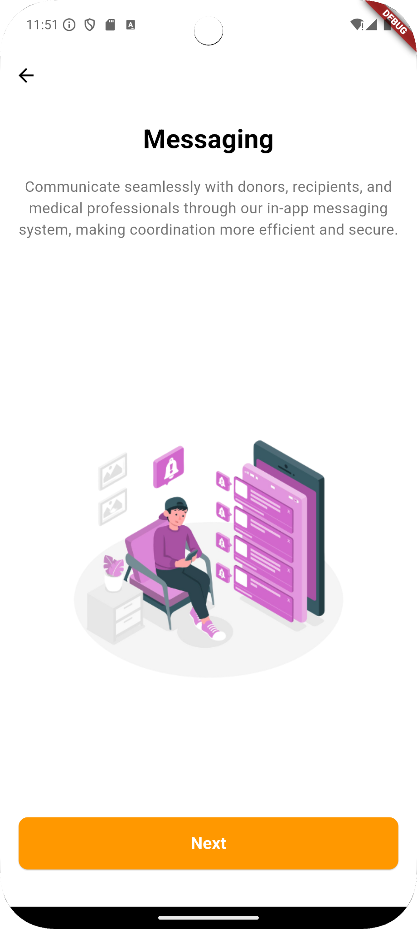

The **Messaging** walkthrough screen in the **Organ Donation App** introduces the in-app communication feature, which enables seamless interaction between users and medical professionals. This feature allows users to communicate directly with donors, recipients, or healthcare providers, making coordination more efficient and secure. It enhances collaboration and speeds up response times, ensuring a streamlined experience in managing organ donation requests and updates.

* **Direct Communication**: Connect with donors, recipients, and healthcare professionals.
* **Enhanced Coordination**: Facilitates efficient exchange of information related to organ requests.
* **Secure Platform**: Ensures user privacy and data security during messaging.
* **Simple Navigation**: The “Next” button guides users smoothly through the app's onboarding process.

**06 Authentication Screen**

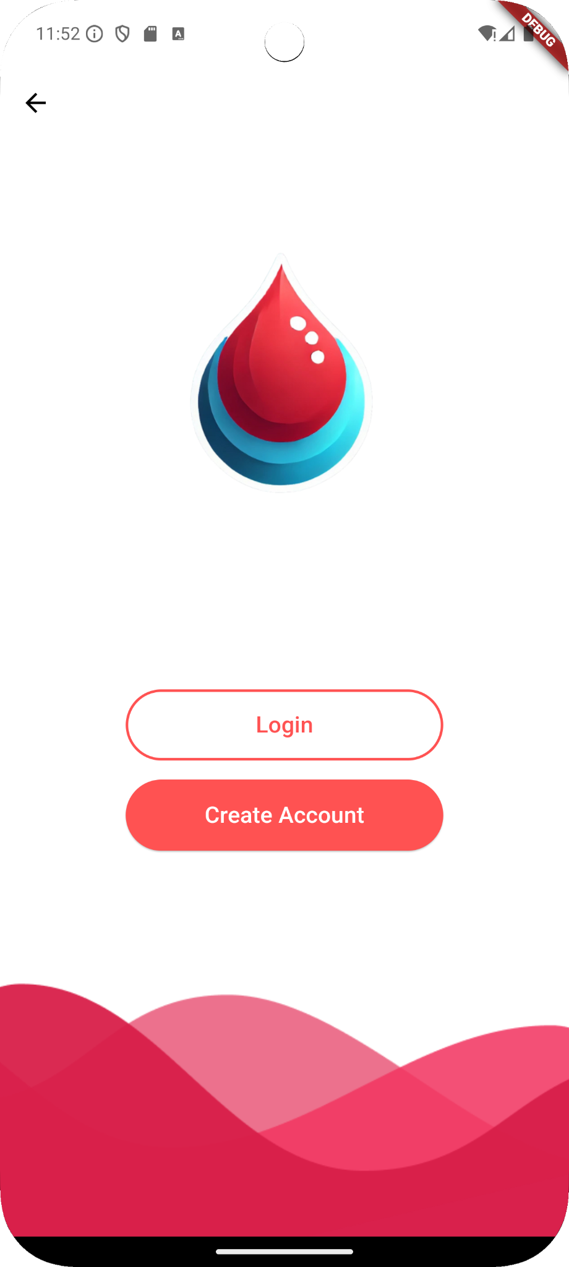

The Authentication Screen provides users with a clear entry point into the Organ Donation App. This screen offers two main options: Login for returning users and Create an Account for new users, making the process of accessing the app simple and efficient. The vibrant design and intuitive layout make it easy for users to begin their journey within the app.

* **Login**: Provides secure access for returning users, ensuring a quick entry into the app.
* **Create Account**: Allows new users to sign up and create an account seamlessly.
* **User-Friendly Interface**: Clean design with prominent buttons for easy navigation.
* **Branding Consistency**: The screen uses colors and visuals consistent with the app’s theme, reinforcing brand identity.

**07 Create New Accounts**

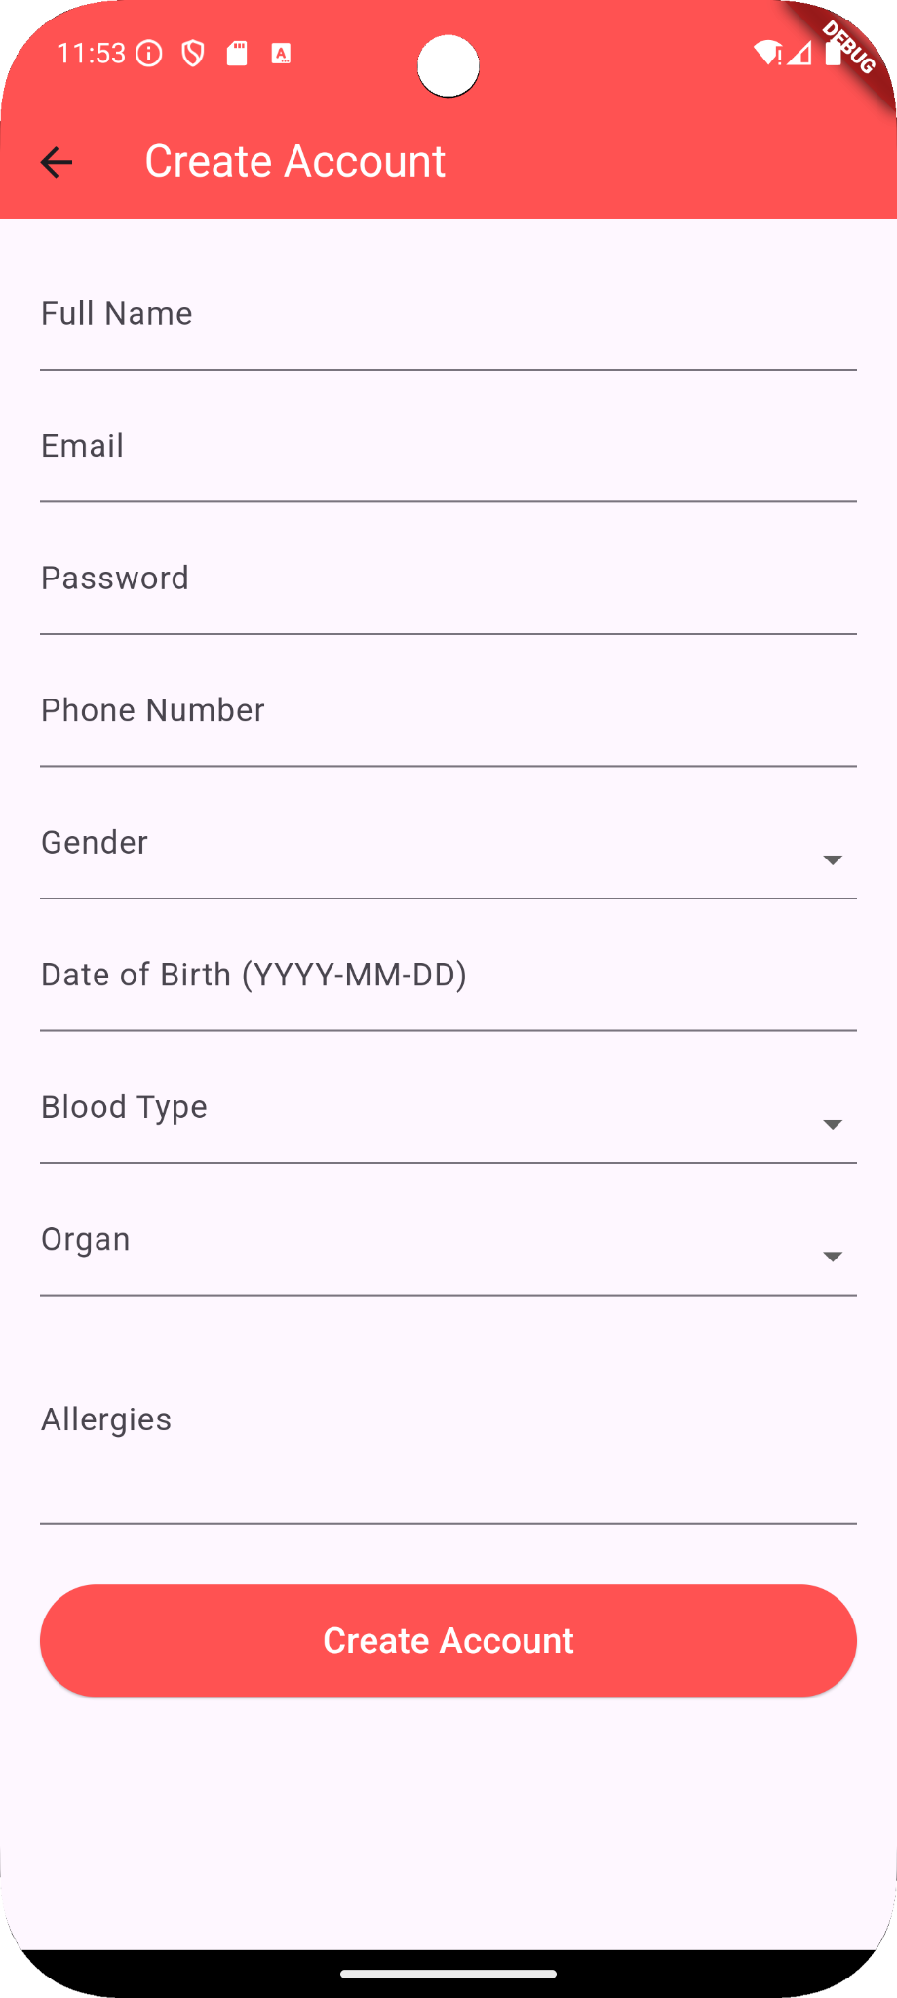

The **Create Account** screen allows new users to register with the **Organ Donation App** by providing essential personal details and medical information. This registration form is designed to gather important details that aid in matching organ needs with availability, ensuring a comprehensive profile setup.

* **Password Setup**: Allows users to create a secure password to protect their account.
* **Gender and Date of Birth**: Captures basic demographic information.
* **Medical Details**: Includes fields for blood type, organ needed, and any allergies, crucial for matching donors with recipients.
* **Simple Navigation**: A "Create Account" button at the bottom enables seamless registration completion.

**08 User Waiting Screen**

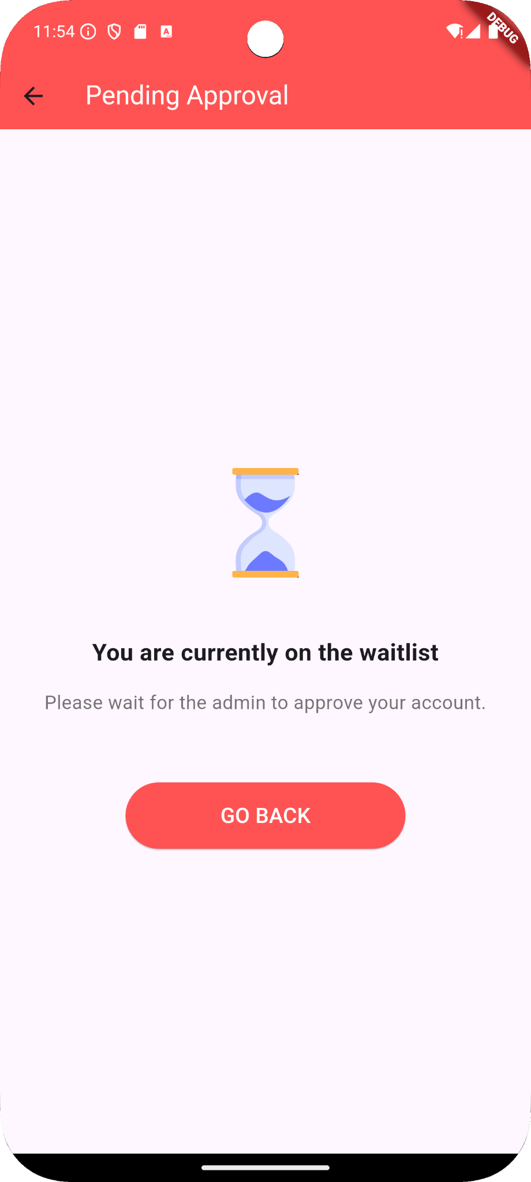

The Pending Approval screen informs users that their account is currently under review by the admin. After completing the registration, users are placed on a waitlist until an admin approves their account. This screen provides a clear status update, helping to manage user expectations during the approval process.

* **Approval Status Notification**: Displays a message indicating that the user is on the waitlist and awaiting admin approval.
* **Visual Indicator**: Includes an hourglass icon, symbolizing the waiting period, for better user experience.
* **Back Navigation**: A "Go Back" button allows users to return to the previous screen or the main interface until they receive approval.

**09 Login Screen**

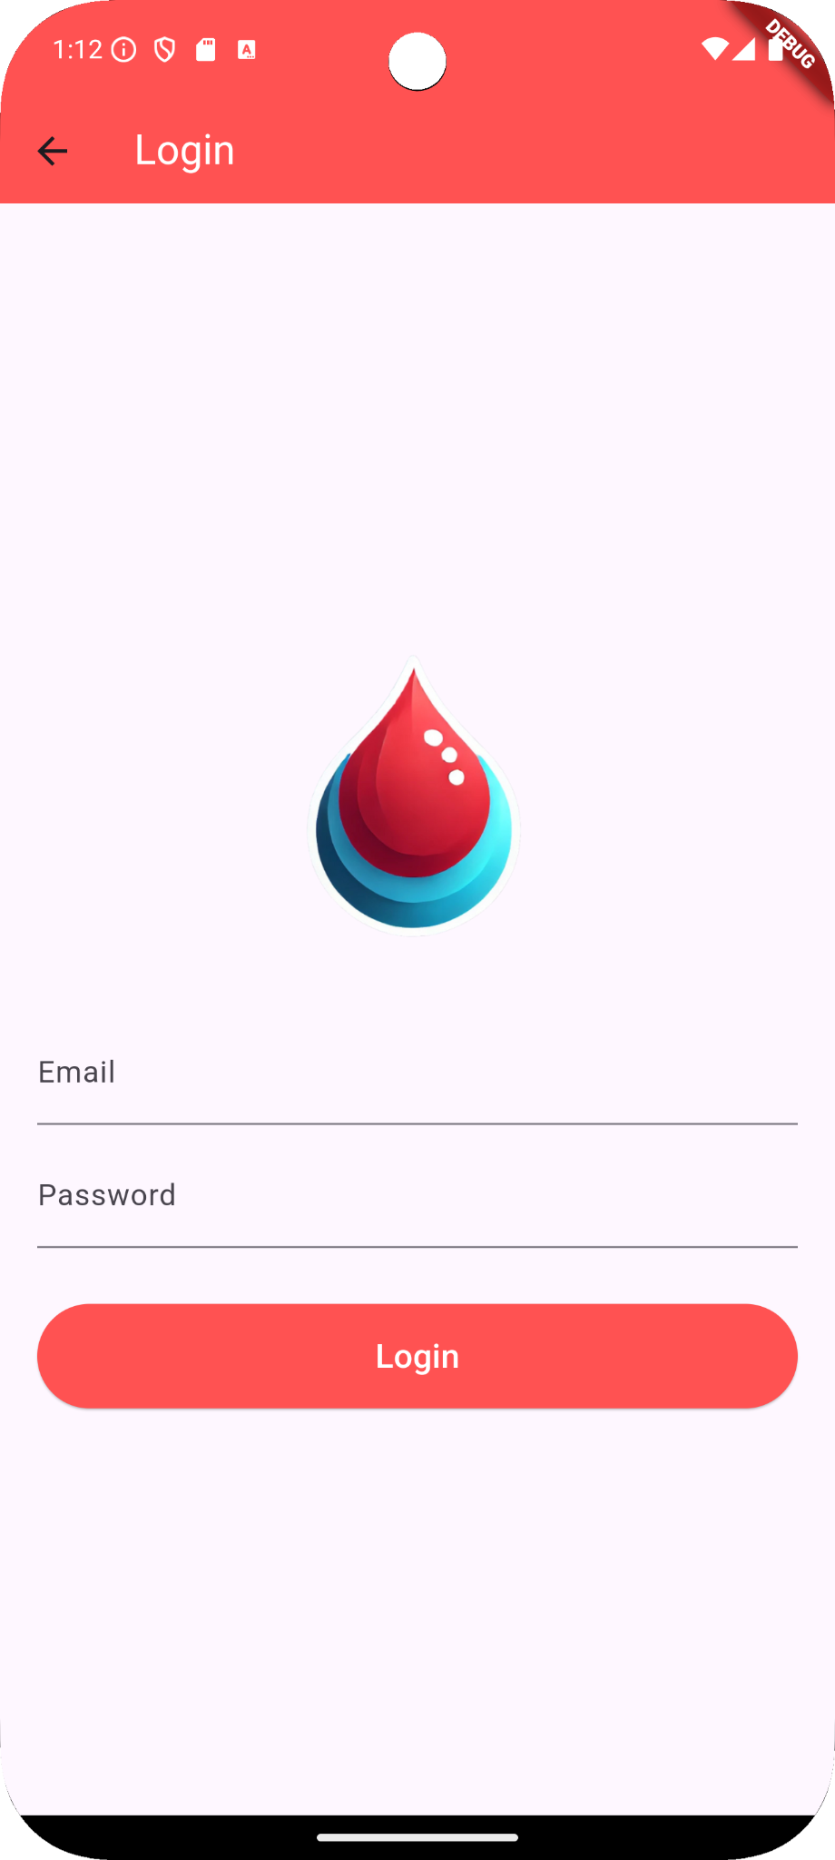

The Login Screen serves as the primary entry point for registered users, allowing them to securely access the app by entering their email and password. Designed with simplicity and clarity, the screen prompts users to authenticate before accessing any features of the app, ensuring that only approved individuals can proceed further.

* **Simple Interface**: Clean and user-friendly, focusing on ease of access.
* **Email and Password Fields**: Input fields for user credentials, supporting secure login.
* **Login Button**: Initiates the authentication process upon being tapped.
* **Error Handling**: Validates input and provides feedback if the email or password is incorrect.
* **Security Measures**: Ensures safe login by handling sensitive user data cautiously.

**10 User Profile Screen**

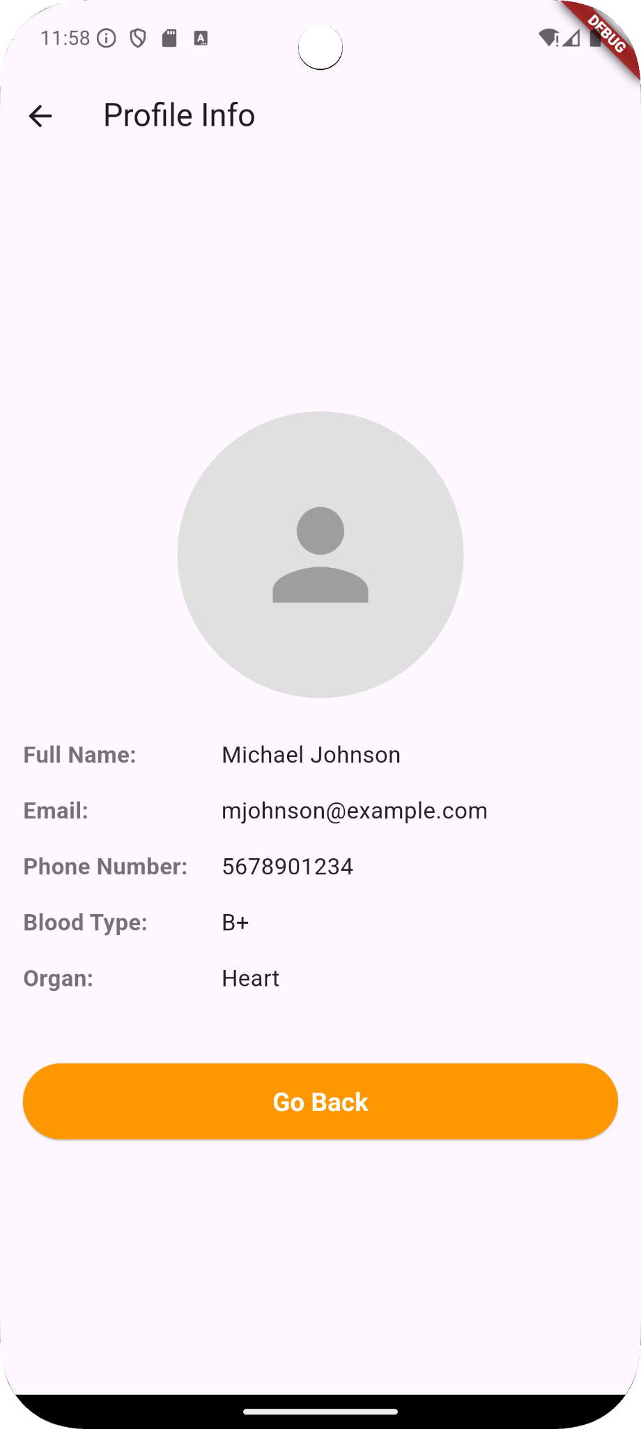

The Profile Info Screen displays essential information about the user, allowing them to view their registered details within the app. This screen provides a simple and organized layout of the user’s personal information, including name, email, contact number, blood type, and the organ they are associated with.

* **User Details Display**: Shows full name, email, phone number, blood type, and organ information.
* **User-Friendly Interface**: Clean and accessible, allowing users to quickly review their details.
* **Navigation**: Includes a "Go Back" button to return to the previous screen, enhancing ease of navigation.

**11 Change Password Screen**

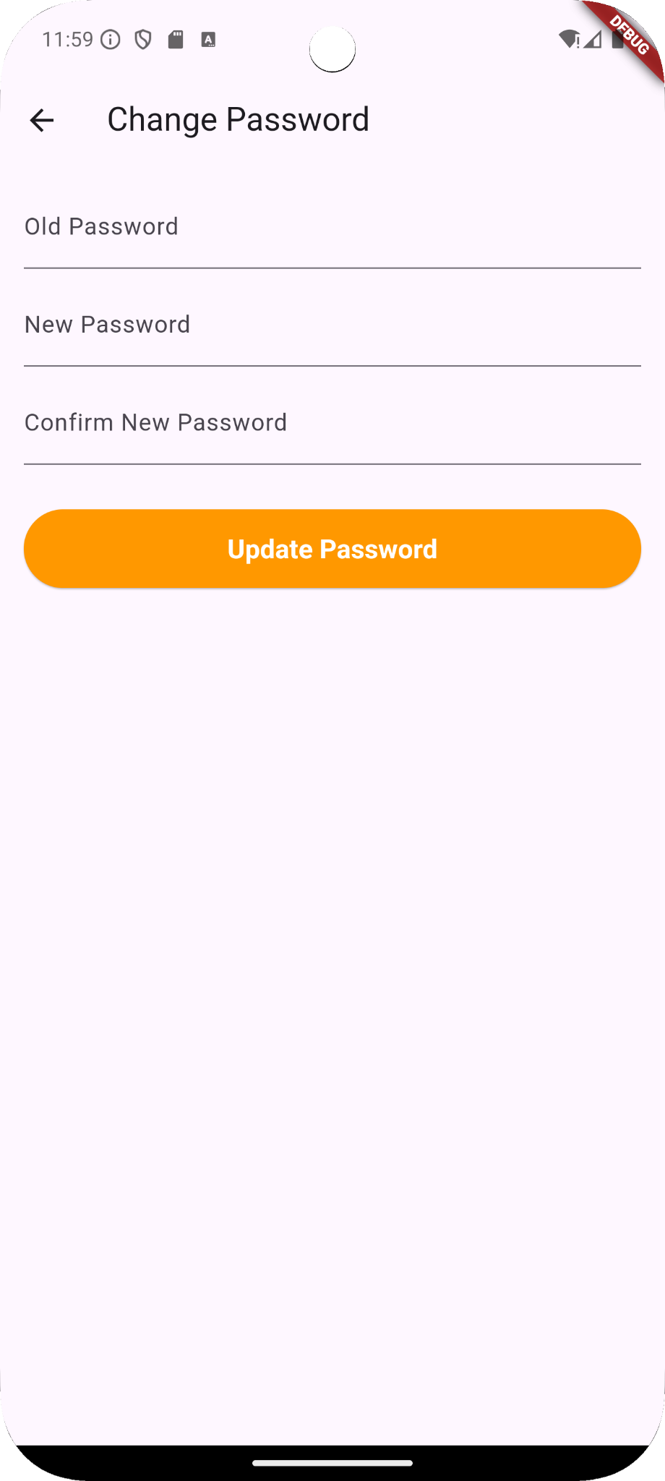

The Change Password Screen enables users to securely update their password. This screen ensures that users can maintain the privacy and security of their accounts by periodically changing their passwords. Users are required to enter their current password, and new password, and confirm the new password to prevent errors.

* **Current Password Verification**: Requires users to input their current password to verify identity.
* **New Password Confirmation**: Users must confirm their new password to avoid mistakes.
* **Secure Password Update**: A straightforward and secure process for updating account credentials.
* **Simple Navigation**: Includes an "Update Password" button to submit the changes easily.

**12 Organ Search Screen**

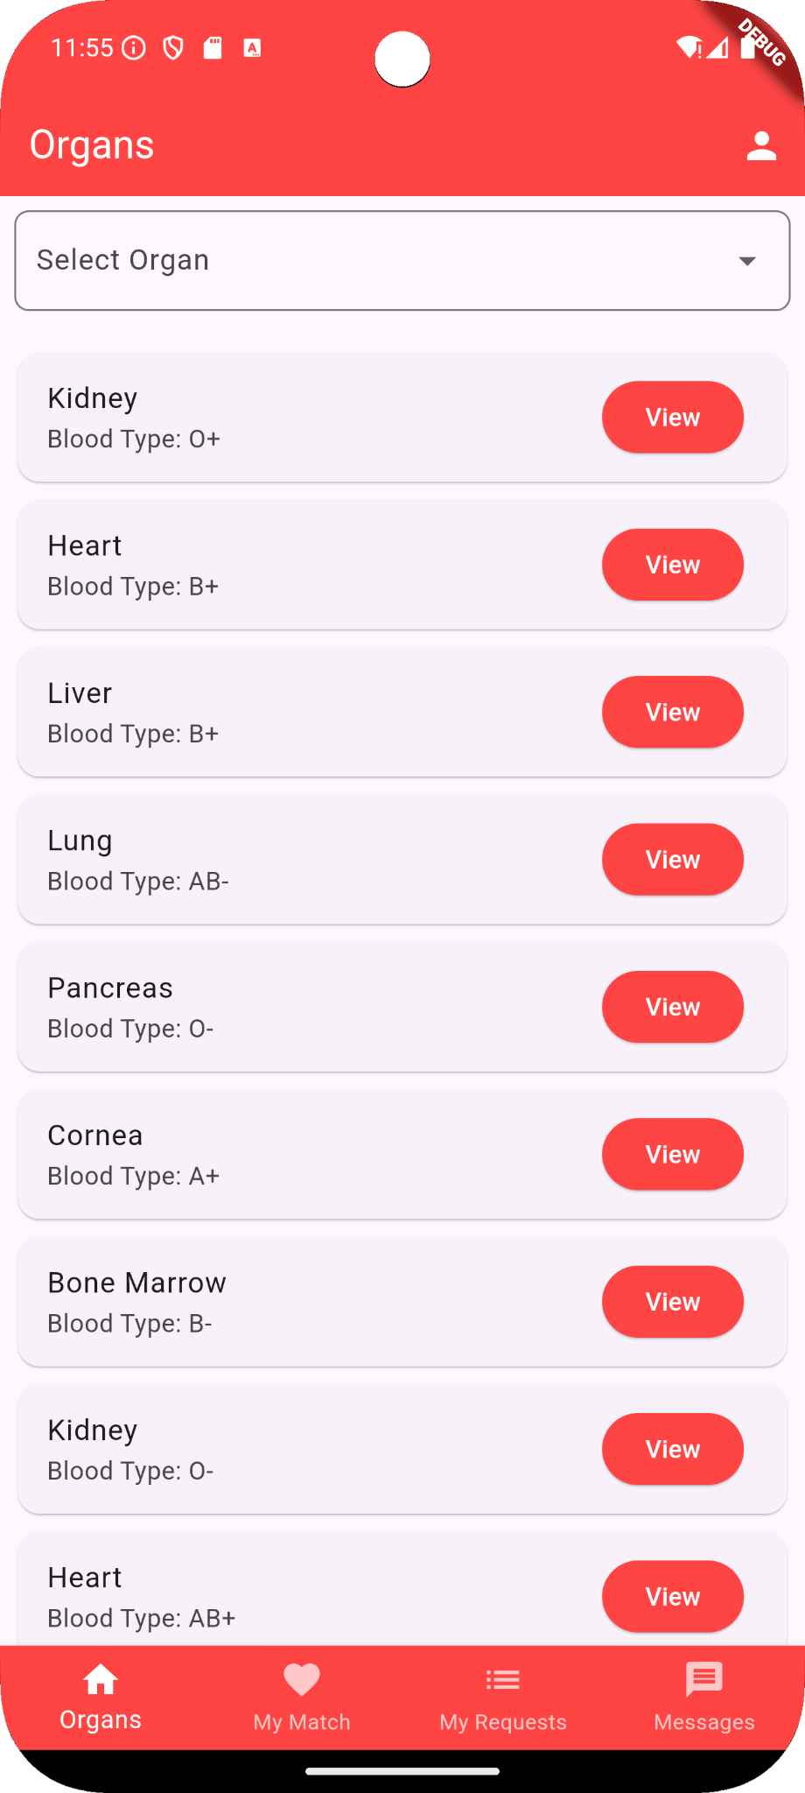

The Organ Search Screen provides users with a streamlined and intuitive way to browse available organs based on their type and blood group. This screen lists each organ with its corresponding blood type, allowing users to quickly identify compatible options. A dropdown menu at the top enables filtering by specific organ types, making it easier to find the right match.

* **Filter by Organ Type**: Users can select an organ type from the dropdown to filter results and streamline the search process.
* **View Button for Details**: Each organ entry has a "View" button, which navigates to a dedicated details screen for more information about the organ.
* **Scrollable List**: Users can scroll through the list to view more organ options beyond the visible screen.
* **Quick Access Tabs**: Navigation tabs at the bottom enable easy switching between sections such as "My Match," "My Requests," and "Messages."

**13 Organ Request Screen**

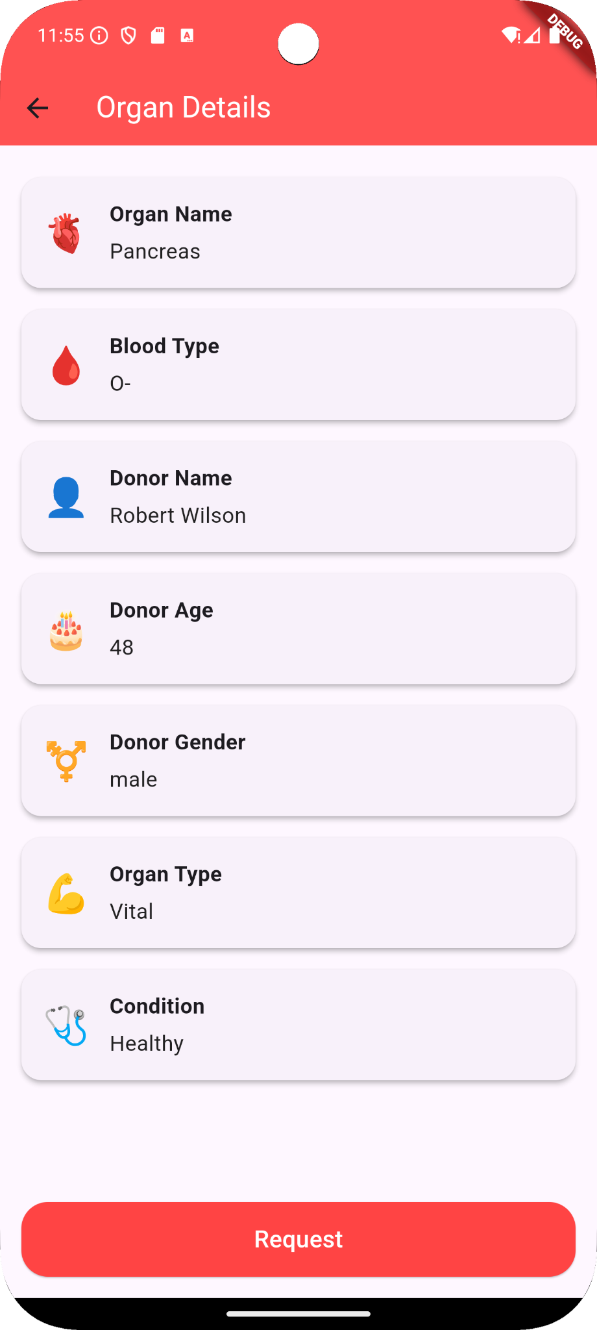

The Organ Details Screen provides comprehensive information about a specific organ available for donation. This screen displays key details such as the organ name, blood type, donor's name, age, gender, organ type, and its condition. Each attribute is accompanied by relevant icons, making the information visually engaging and easy to read.

* **Detailed Organ Information**: Presents all necessary details about the organ and the donor, aiding the recipient in making an informed decision.
* **Request Button**: Allows users to request the organ by clicking the "Request" button, initiating the process for further consideration and potential matching.
* **User-Friendly Design**: Icons alongside text enhance readability, ensuring the interface is approachable and visually appealing.

**14 Organ View Screen**

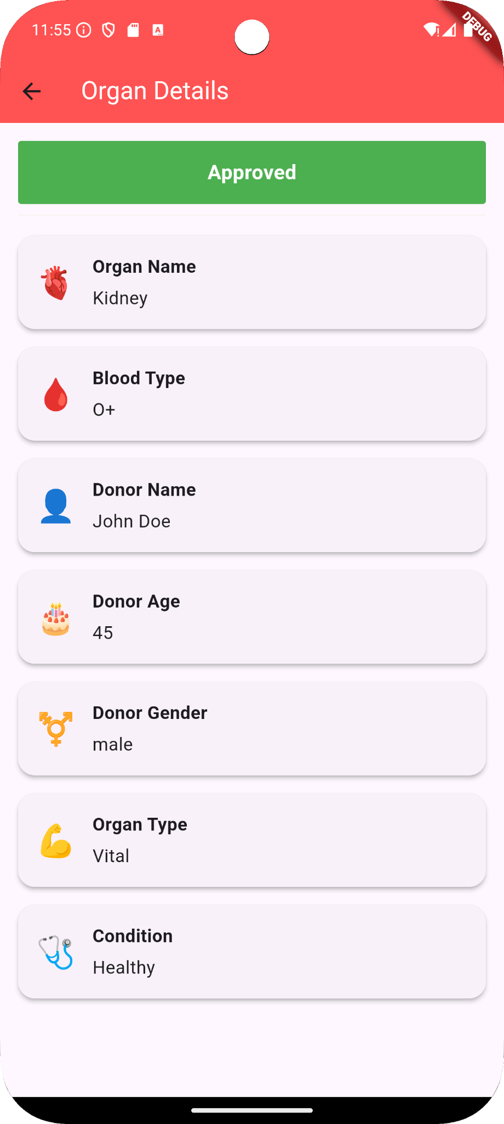

The **Organ Details Screen** provides users with an in-depth view of an organ's information, showing all relevant details such as organ name, blood type, donor information (name, age, gender), organ type, and condition. Additionally, it includes a **status indicator** at the top, which displays the current status of the user's request:

* **Pending**: Shown in gray, indicating the request is still under review.
* **Rejected**: Displayed in red, signaling that the request was declined.
* **Approved**: Marked in green, showing that the request has been accepted.

**15 My Matches Screen**

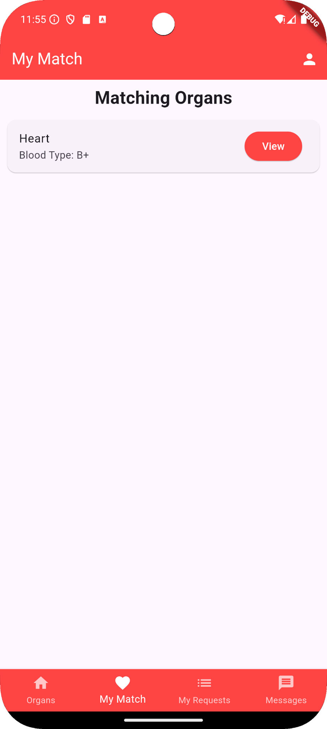

The My Matches Screen displays all organs that match the user's specified blood type and organ requirements. This screen simplifies the organ search process by automatically filtering and listing compatible organs, making it easy for the user to identify potential matches. Each matching organ entry shows the organ type and blood type, along with a "View" button, allowing the user to navigate to a detailed view for further information. This streamlined matching feature enhances user experience by providing quick access to relevant organ options based on compatibility.

* Displays a list of organs that match the user’s specified blood type and needed organ.
* Provides a simplified, filtered view of compatible organs, enhancing the user experience.
* Each entry includes key information, such as organ type and blood type, for quick identification.
* Features a "View" button for each organ entry, allowing users to see detailed information.
* Automatically updates to show all available matching organs, saving users time in their search.

**16 My Requests Screen**

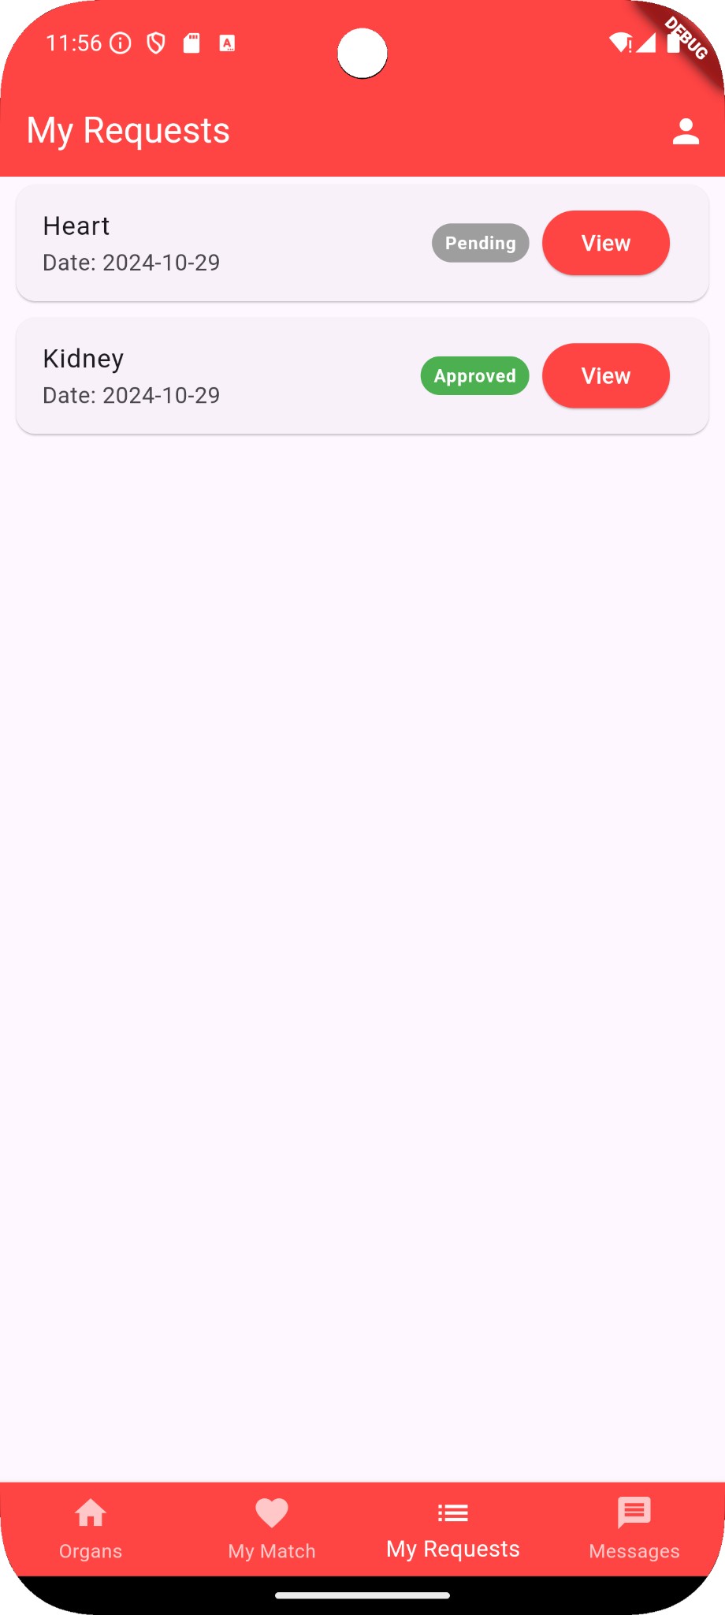

The My Requests Screen provides users with a streamlined view of all the organs they have requested. Each entry shows essential information such as the organ type and the date of the request, allowing users to keep track of their application history. Requests are clearly marked with status tags that indicate whether a request is pending, approved, or rejected, with intuitive color-coding: gray for pending, green for approved, and red for rejected.

* Displays a list of all organs that the user has requested.
* Shows key details, including the organ type and request date.
* Each request has a status tag, such as:
  + Pending (gray) for requests still awaiting approval.
  + Approved (green) for requests that have been accepted.
  + Rejected (red) for requests that have been declined.
* Users can click the View button to see more detailed information about each request.

**17 Messaging**

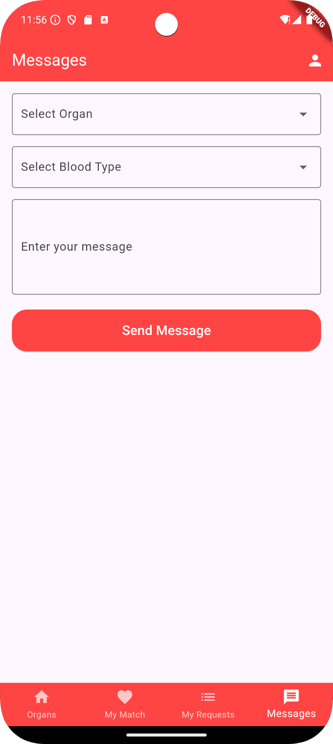

The Messaging Screen in this organ donation app provides users with a direct communication channel to reach out to hospitals regarding their organ needs. This feature facilitates streamlined interaction, ensuring requests are handled efficiently. Here, users can select an organ type and blood type, compose a message detailing their request, and send it to the hospital for review. This setup enhances the chances of receiving timely support from medical institutions. Once a message is sent, hospital representatives can review the request and initiate contact with the user via phone for further assistance.

* **Organ Selection**: Users can specify the organ they need, ensuring clarity in their request.
* **Blood Type Selection**: Adding the blood type helps hospitals prioritize compatible organ matches.
* **Custom Message Input**: Users can enter specific details or requirements to communicate their needs better.
* **Send Message Button**: A straightforward button for users to submit their request to the hospital.

**18 Message Sent Screen**

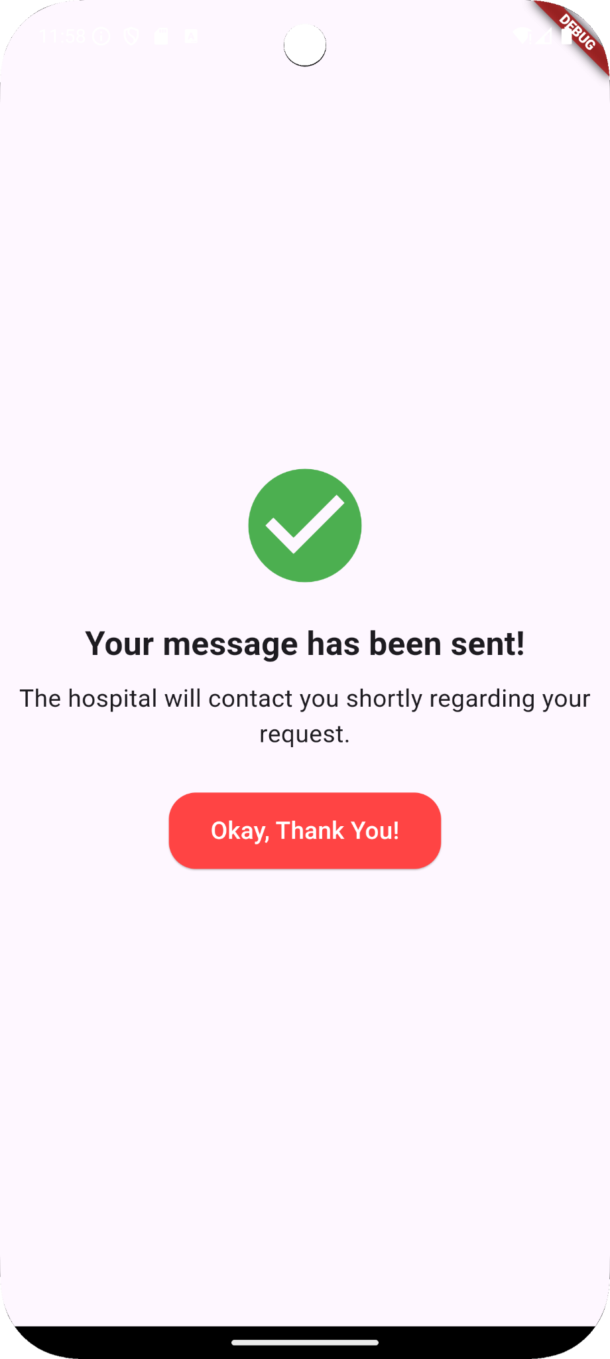

The Message Sent Confirmation Screen is a reassuring step in the communication process of the organ donation app. After a user sends a message to the hospital, they are directed to this screen to confirm that their message has been successfully delivered.

* **Clear Confirmation Message**: "Your message has been sent!" assures the user that their request has reached the hospital.
* **Next Steps Information**: A follow-up message informs the user that the hospital will contact them shortly regarding their request, setting the right expectations.
* **Acknowledgment Button**: The "Okay, Thank You!" button provides a simple way for users to exit this screen and continue navigating the app.